**PERSONAL BLOG ON IBM CLOUD STATIC WEB APPS**

**Phase 3 Submission Document**

|  |  |
| --- | --- |
| NAME | Shanu S G |
| TEAM ID | 8935 |
| TEAM NAME | Proj_207157_Team_2 |
| PROJECT NAME | 8301-Personal Blog on IBM Cloud Static Web Apps |
| SUBMISSION DATE | 25-10-2023 |

**Introduction:-**

In this phase, the website layout design has been entirely finalized. It now includes the essential, user-engaging content, such as captivating stories and valuable travel tips. These additions are expected to enhance user engagement and potentially increase website traffic. We are pleased to submit this document, which marks the culmination of the static travel blog website.This document serves as a comprehensive guide to the website, outlining the various aspects of its development, design and functionality.

**Objective:-**

The main purpose of this document is to provide a detailed overview of the work done during the website development. It will help you understand the project's goals, the technologies we used, the design decisions we made, and the features we added.

**Technical stack:-**

HTML

CSS

Python – Flask

**Software used:-**

VS Code

**Website pages :-**

Home page

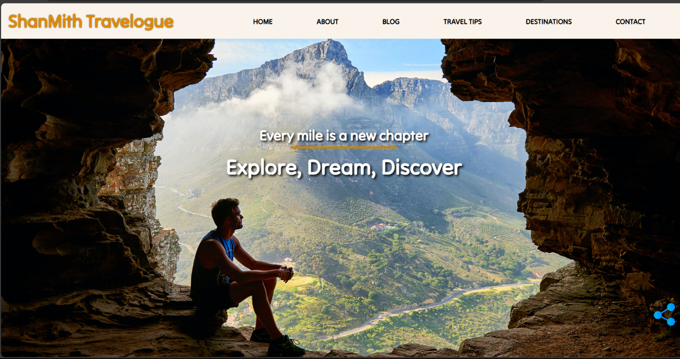Discover captivating destinations, read insightful travel tips, and embark on adventures from the comfort of your screen.

About page

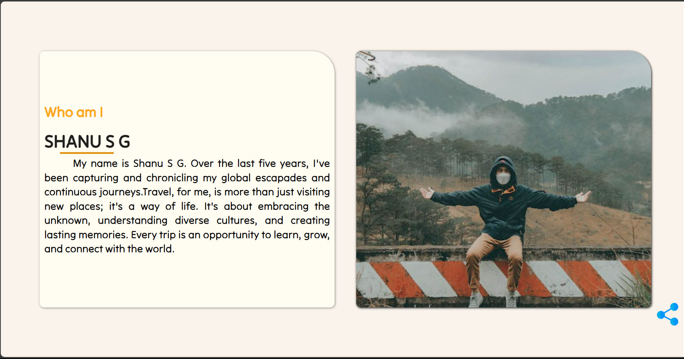We are a passionate group of explorers sharing our love for travel with the world. Learn about our journey, mission, and the individuals who bring our travel stories to life.

Blog Page

Explore the world through our eyes with the latest blog posts from us.

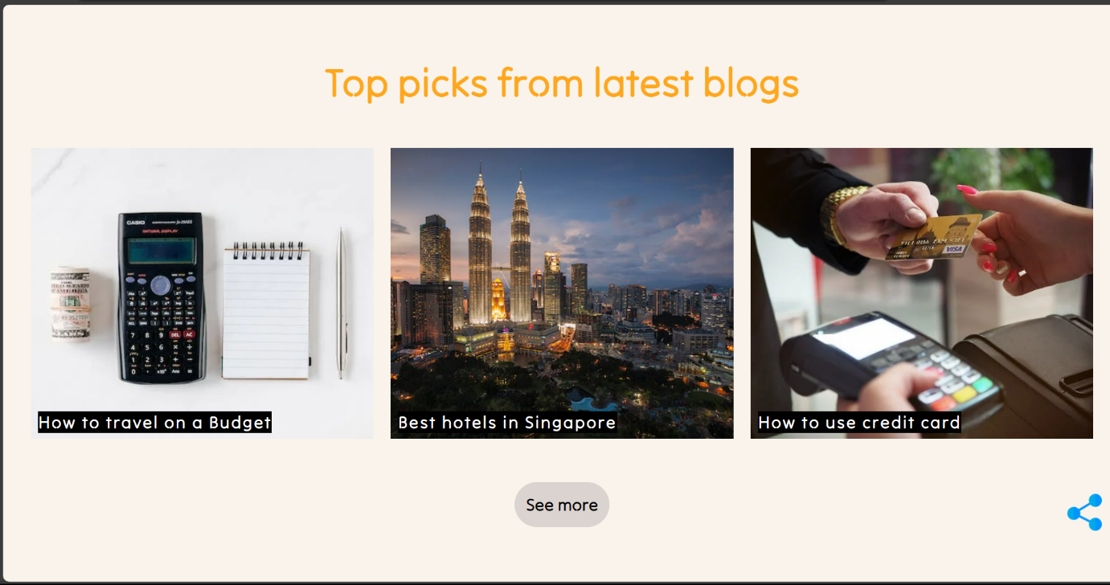

Travel tips page

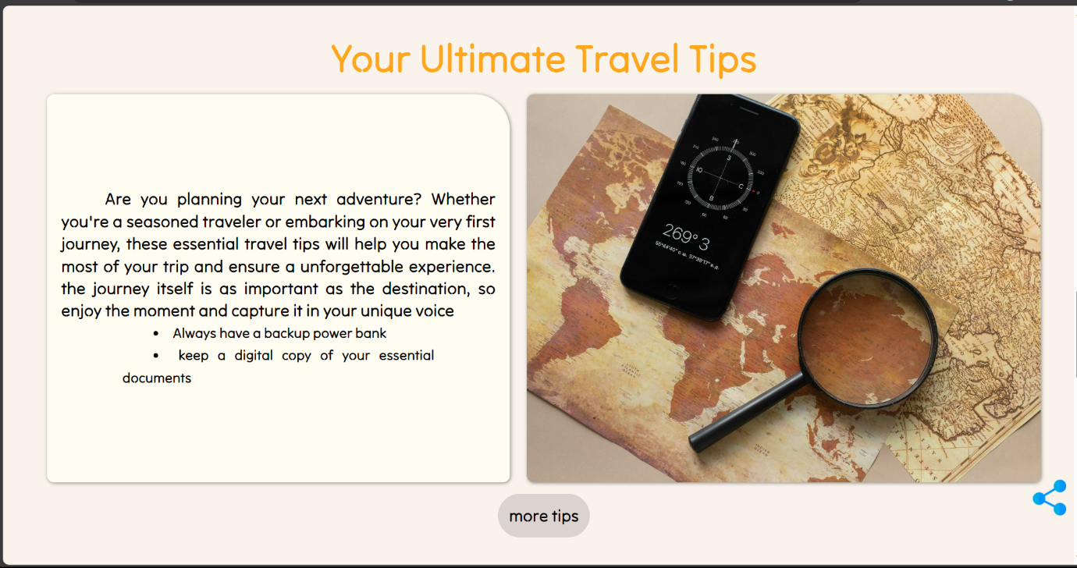Our tips page is your guide to travel wisdom, from packing hacks to cultural insights. Join us on a journey of discovery, empowerment, and the art of smart and enriching travel.

Destination page

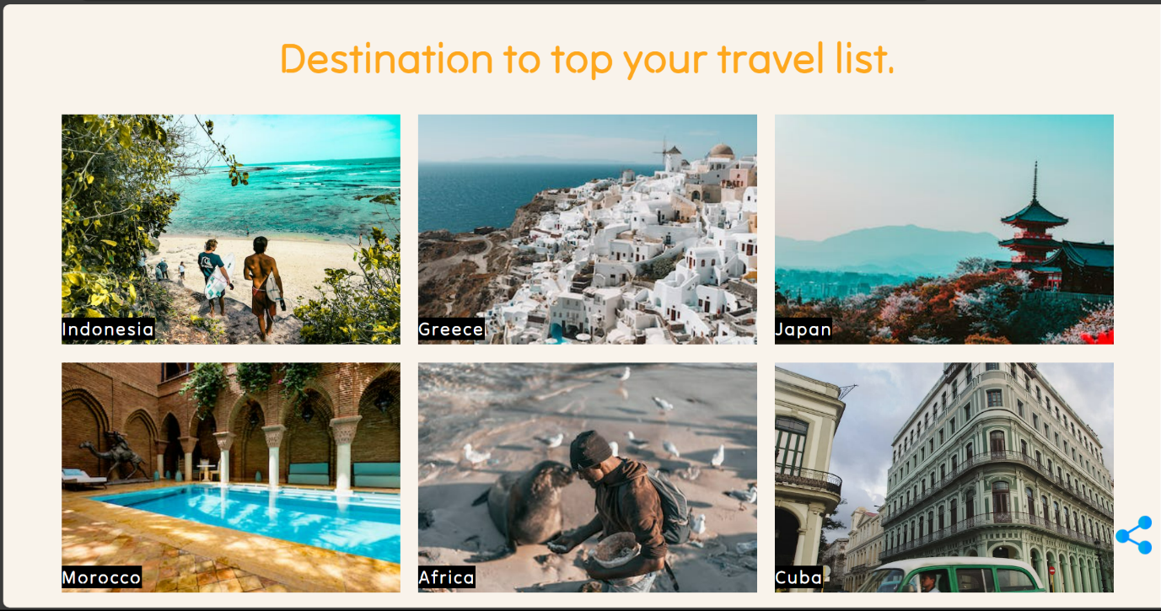Each destination is a unique chapter in your travel story, offering a kaleidoscope of experiences waiting to be explored.

Contact page

Your voice matters, and we're here to listen, respond, and engage with you. Whether you have questions, feedback, or simply want to reach out, drop us a message, and we'll get back to you as soon as possible.

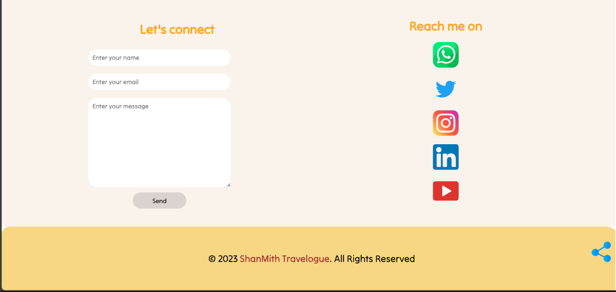

**Sample code:-**

HTML

<!DOCTYPE html>

<html lang="en">

<head>

    <meta charset="UTF-8">

    <meta name="viewport" content="width=device-width, initial-scale=1.0">

    <title>Travel blog</title>

    <link rel="stylesheet" type="text/css" href="{{ url_for('static', filename='css/style.css') }}">

</head>

<body>

    <!-- <h1>Welcome to the home page</h1> -->

    <!-- header starts -->

    <header id="home-sec">

        <!-- navbar starts -->

        <nav class="navbar">

            <img class="menu-btn" src="{{url_for('static',filename='images/menubtn.png')}}" alt="menu-btn">

            <div class="logo">

                <h1>ShanMith Travelogue </h1>

            </div>

            <ul class="links">

                <li><a href="#home-sec">HOME</a></li>

                <li><a href="#about-sec">ABOUT</a></li>

                <li><a href="#blog-sec">BLOG</a></li>

                <li><a href="#tips-sec">TRAVEL TIPS</a></li>

                <li><a href="#destination-sec">DESTINATIONS</a></li>

                <li><a href="#contact-sec">CONTACT</a></li>

            </ul>

        </nav>

        <!-- navbar ends -->

    </header>

CSS

header {

*font-size*: 2.5vmin;

*width*: 100vw;

*height*: 10vh;

}

.logo {

*display*: flex;

*justify-content*: start;

*align-items*: center;

*height*: 100%;

*width*: 30%;

*cursor*: pointer;

*color*: rgb(255, 255, 255);

*margin-left*: 2vmin;

}

Python-Flask

from flask import Flask,render_template

app = Flask(__name__)

@app.route('/')

@app.route('/home')

*def* hello_world():

    return render_template('index.html')

# Run the Flask app

if __name__ == '__main__':

    app.run(*debug*=True)

**Note:-** The above provided code is a sample for reference and demonstration purpose.

**Conclusion:-**

In conclusion, my personal travel blog has been a labor of love, a shared journey, and a digital diary of my adventures around the world. With every story, photo, and tip I've shared, my goal has been not only to record my own travels but also to inspire and help fellow travelers in their exploration quests.